Here's what you requested plus another.
The new photo shows one of my plastic templates in a runner that has been ported.
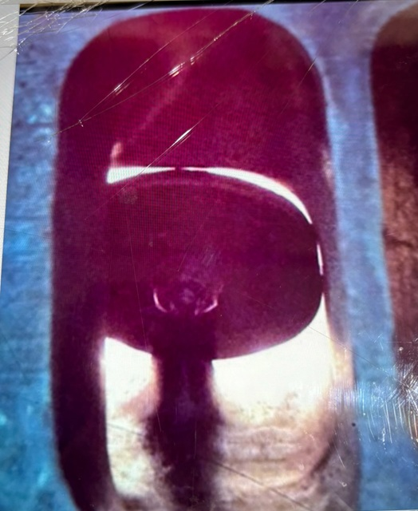
Note that the flat side ( 94% side) is on the common wall and how the floor below the crown of the short turn is now from rework more U shaped then round like the template.
Note that the template can not make it up to the crown of the short turn due to the valve guide.
If you’re going to keep the valve guide and not put in a new 1/2" guide then if you cut a V into the template, you can get it up and onto the crown of the short turn to both gauge your port width and height.
Note that making a plastic template with its 6/32" handle allows you to much easier get the template into the runner because of the lesser diameter then having a 11/32" valve stem which makes for a steeper angle.
Once again note heads with a shallow spark plug side of the chamber this does not matter as much since it allows you to hold the template on a lesser angle.
Also, in terms of the short turn solder photo, note that this is the arc of the center run of the short turn.
Each side of the short turn where it meets each vertical wall can need a slightly different arc to it depending on the valve inclination angle the head has.
For production iron SBC heads with a 23 degree angle the lateral arc around the short turn from the common wall to the floor needs to be more gradual then the exh valve side.
I fact the exh valve side of the short turn can be smaller in height then the common wall side.
But if you do not have access to a flow bench it's best to not drop that exh valve arc to not more then .040".

